|  |
| --- |
| By Cliff Rodriguez |
| Problem Set 4 |
| Date: Due March 14, 2018 |

|  |
| --- |
| Cliff Rodriguez |

Contents

**No table of contents entries found.**

**No table of figures entries found.**

# Question 1

1. Number
2. SSR and Standard Error calculation
3. 

$${log⁡(rent)}_{i}= -3.37+.03{ log⁡(pop}_{i})+{.877 log⁡(avginc}_{i})+{.01 pctstu}_{i}+u_{i}$$

Interpretations:

${\hat{β}}_{0}$– when the population is 1, the average income is 1, and the percent of students is zero, the expected log(rent) value is -3.37.

${\hat{β}}_{1}$– a ten percent increase in population is expected to increase rent by 3 percent, holding average income and the percentage of the population that is students constant.

${\hat{β}}_{2}$– a one percent increase in population is expected to increase rent by 8.77 percent, holding average income, and the percentage of the population that is students constant.

${\hat{β}}_{3}$– a 10 percent increase in the percentage of the population that is students is expected to increase rent by 1 percent, holding population and average income constant.

$$H_{0}: β_{3}=0$$

$$H_{A}: β_{3}≠0$$

$$τ_{α = .05}= \frac{.0065849-0}{.0012027}=5.475$$

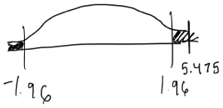

5.475 ∈ of CR; we reject the null.

1. I am unable to say, with confidence that ${\hat{β}}_{3}$ is unbiased. There is a potential for reverse causality, higher rents could cause the percentage of the population that is students.
2. Subsidiary regression
3. SSR and (n-k)
   1. Calculation of standard error

$$H_{0}: β_{}=0$$

$$H_{A}: β_{}≠0$$

1. Joint hypothesis test
2. Estimate the restricted model
3. SSR, F-statistic, compare with F stat in STATA

# Question 2

1. Interpretations:

$${\hat{β}}_{0}$$

$${\hat{β}}_{1}$$

$$H_{0}: β_{1}=0$$

$$H_{A}: β_{1}≠0$$

$$τ_{α = .05}= \frac{2.5-0}{1.25}=2.0$$

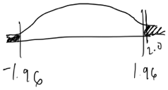

2.0 ∈ of CR; we reject the null.

GET HELP WITH P-VALUE

The result that there is an effect is expected because a positive sign on ${\hat{β}}_{1}$ is not expected.It would be expected that having government provided water would decrease the number of days someone felt sick in the last month.

1. Show relationships for si if …..
2. Not sure on this one….
3. Adding a variable for birth month will not affect the estimate of the effect of the clean water program.
4. I would include a dummy variable for chronic illness, where:

c_illness = 1 if someone has been diagnosed with a chronic illness

# Question 3

1. E(u) = 0 , under assumptions 1 and 4 allows us to conclude that E(${\hat{β}}_{0}$) = $β_{0}$, and to conclude that $β_{0}$ is unbiased and that ${\hat{β}}_{0}$ is an unbiased estimator of $β_{0}$.
2. $β_{0}$ is interpreted as if price of a diamond if the carat value is zero. This does not make intuitive sense because a value of zero carats does not correspond to a diamond of any type in real life.

$$H_{0}: β_{1}=5200$$

$$H_{A}: β_{1}≠5200$$

$$τ_{α = .05}= \frac{5573.34-5200}{187.14}=1.995$$

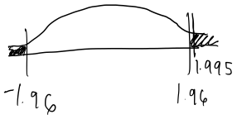

1.995 ∈ of CR; we reject the null.

1. Comparing:

$R_{1}^{2}$ = .647

$R_{2}^{2}$ = .058

Carats is a stronger predictor of price than color. 64.7% of the variation in price is explained by carats, versus 5.8% of the variation in price is explained by color, according to the models estimated.

$$H_{0}: β_{1}>0$$

$$H_{A}: β_{1}≤0$$

$$τ_{}= \frac{649.95 - 0}{100.07}=6.5$$

$${CR}_{α = .05}=1.65$$

This is a one-sided test.

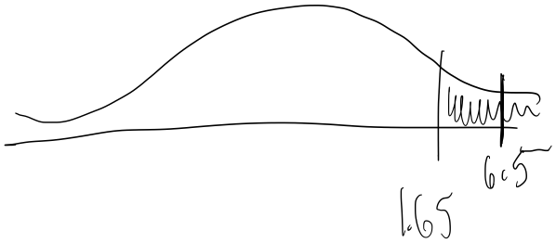

6.5 ∈ of CR; we reject the null.